***Onesnaženost vodnih virov gozdnega ekosistema***

Ali ste se kdaj vprašali, kaj bi se zgodilo, če bi vsa pitna voda postala onesnažena? Zdi se skoraj nepredstavljivo vendar se iz dneva v dan bližamo uresničenju krize. Danes že več kot 2 milijardi ljudi nima dostopa do varne pitne vode, in to število se hitro povečuje. A kaj, če bi naš vir vode iz danes na jutri izginil ali se močno poslabšal? Kakšne bi bile posledice za naše zdravje, okolje in svetovno gospodarstvo?

Gozdovi so ključni ekosistemi, ki zagotavljajo življenjski prostor za številne vrste, proizvajajo kisik in uravnavajo podnebje. Poleg tega filtrirajo vodo in ohranjajo kakovost vodnih virov, ki so bistveni za preživetje mnogih rastlinskih in živalskih vrst. Vendar pa so ti vitalni ekosistemi vse bolj ogroženi zaradi onesnaževal, ki vstopajo v njihove vodne vire.

Onesnažena voda v gozdnih ekosistemih ima številne negativne učinke. Strupene snovi, kot so pesticidi in težke kovine, škodujejo vodnim organizmom, kar vodi v zmanjšanje biotske pestrosti. Ko te kemikalije preidejo v prehranjevalne verige, lahko vplivajo tudi na večje živali in celo ljudi. Poleg tega kisli dež, ki nastane zaradi industrijskih emisij, znižuje pH vrednost vode, kar še dodatno ogroža občutljive vrste, ki živijo v teh vodah.

Ena izmed hujših posledic onesnaženja je tudi erozija tal. Ko onesnažena voda teče skozi gozdna območja, lahko izpere hranila in onesnaževalce v vodne tokove, kar škoduje kakovosti vode in poslabša stanje gozdnih tal.

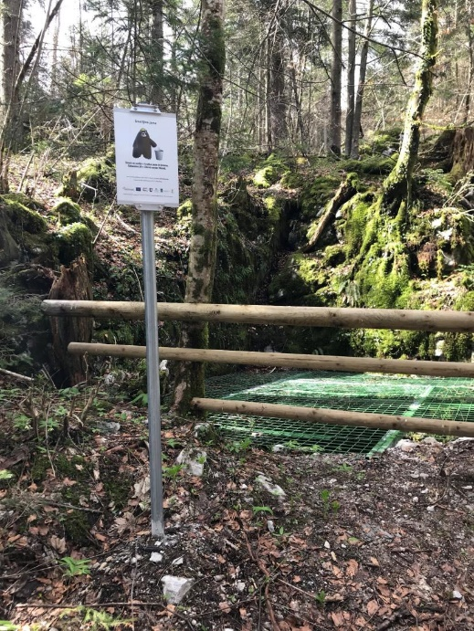

Slika 1: (vir:[https://www.google.com/url?sa=i&url=https%3A%2F%2](https://www.google.com/url?sa=i&url=https%3A%2F%2Fwww.kocevje.si%2Fobjava%2F186628&psig=AOvVaw3Y9k_-5dGwCGhC94ZjcdH3&ust=1742555751265000&source=images&cd=vfe&opi=89978449&ved=0CBQQjRxqFwoTCPDNoprEmIwDFQAAAAAdAAAAABAE))

V Kočevju na onesnaževanje vode in podtalnice vplivajo mnogi nezakonito odlaganje odpadkov in prekomerna raba vodnih virov, glavni atributi pa so kmetijstvo in širše prebivalstvo. Kmetijstvo včasih vključuje uporabo velike količine sintetičnih gnojil in pesticidov za povečanje pridelkov. Te kemikalije se lahko izpirajo iz tal v podtalnico in površinske vode, kar povzroči onesnaženje. Nitrati, ki so pogosti v gnojilih, so še posebej problematični, saj lahko onesnažijo pitno vodo in povzročijo zdravstvene težave. Nezakonito odlaganje smeti in nevarnih odpadkov pa v naravo pridejo preko vode do kontaminacije tal in vode. Toksini iz odpadkov, kot so plastika, težke kovine, olja in kemikalije, lahko z dežjem ali taljenjem snega dosežejo vodne vire.

Te probleme bi rešili z uporabo ekoloških gnojil, uvedbe preciznega kmetijstva, zaščito tal ter kmetijskih subvencij. Tako bi se delež kmetijskega onesnaževanja znatno zmanjšal. Te spadajo med ene izmed mnogih rešitev, ki bi pripomogle k izboljšani kakovosti okolja, zdravju ljudi in trajnostnem razvoju v Kočevju.

**Viri:**

Levstek, S. (27.. 9. 2018). *Kočevje.si*. Pridobljeno iz LIFE pod nami - onesnaževanje podzemnih voda na Kočevskem: https://www.kocevje.si/objava/186628

Nunez, C. (16.. Marec 2010). *National geographic*. Pridobljeno iz Water pollution is a rising global crisis. Here’s what you need to know.: https://www.nationalgeographic.com/environment/article/freshwater-pollution

Avtorja: Sašo Radivojevič, Rok Novak

***Pollution of Water Sources in the Forest Ecosystem***

Have you ever wondered what would happen if all drinking water became polluted?  
It seems almost unimaginable, yet we are moving closer to this crisis every day.  
Today, more than 2 billion people lack access to safe drinking water, and this number is rapidly increasing. But what if our water sources disappeared overnight or deteriorated significantly? What would be the consequences for our health, the local environment, and the global economy?

Forests are key ecosystems that provide habitats for numerous species, produce oxygen, and regulate the climate. They also capture and store water. In addition, they filter water and maintain the quality of water sources, essential for the survival of many plant and animal species. However, these vital ecosystems are increasingly threatened by pollutants entering water sources.

Polluted water in forest ecosystems has numerous negative effects. Toxic substances, such as pesticides and heavy metals, harm aquatic organisms, which leads to a decline in biodiversity. When these chemicals enter food chains, they can also affect larger animals and even humans. Furthermore, acid rain, resulting from industrial emissions, lowers the pH value of water, further endangering sensitive species living in these waters.

One of the most severe consequences of pollution is soil erosion. When polluted water flows through forest areas, it can wash nutrients and contaminants into water streams, damaging water quality and degrading the forest ground. This reduces the soil's ability to retain water and nutrients, affecting both plants and animals in the forests.

In the Kočevje region, water and groundwater pollution are influenced by various factors, such as industrial activities, illegal waste disposal, and excessive use of water resources. However, the primary contributors are agriculture, municipal waste, and sewage systems.

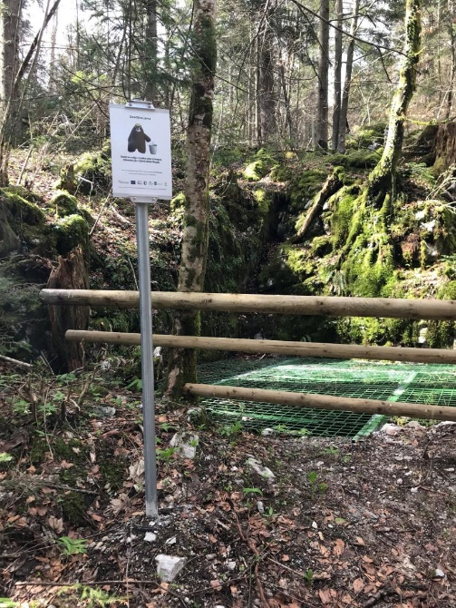

Slika 1: (vir:[https://www.google.com/url?sa=i&url=https%3A%2F](https://www.google.com/url?sa=i&url=https%3A%2F%2Fwww.kocevje.si%2Fobjava%2F186628&psig=AOvVaw3Y9k_-5dGwCGhC94ZjcdH3&ust=1742555751265000&source=images&cd=vfe&opi=89978449&ved=0CBQQjRxqFwoTCPDNoprEmIwDFQAAAAAdAAAAABAE))

Agriculture often involves the use of large amounts of synthetic fertilizers and pesticides to increase yields. These chemicals can be leached from the soil into groundwater and surface water, causing pollution. Nitrates, commonly found in fertilizers, are particularly problematic as they can contaminate drinking water and cause health issues. Illegal dumping of waste and hazardous materials leads to contamination of soil and water. Toxins from waste, such as plastics, heavy metals, oils, and chemicals, can reach water sources through rain or melting snow.

These problems could be addressed by using organic fertilizers, implementing precision agriculture, protecting soil, and providing agricultural subsidies. This would significantly reduce agricultural pollution. Pollution caused by municipal waste and sewage could be mitigated by upgrading sewage systems, improving wastewater treatment plants, and enhancing waste management. These are just a few of the many solutions that could contribute to improving environmental quality, human health, and sustainable development in the region. Luckily, we do not have any trouble with polluted waters in Kočevje that is why we can be satisfied that we live in this enviroment.

**Sources:**

Levstek, S. (27.. 9. 2018). *Kočevje.si*. Pridobljeno iz LIFE pod nami - onesnaževanje podzemnih voda na Kočevskem: https://www.kocevje.si/objava/186628

Nunez, C. (16.. Marec 2010). *National geographic*. Pridobljeno iz Water pollution is a rising global crisis. Here’s what you need to know.: https://www.nationalgeographic.com/environment/article/freshwater-pollution

Authors: Sašo Radivojevič, Rok Novak