**GOZDNI BONTON**

**Gotovo ste že slišali pravljico o gozdnem bontonu. Nekoč pred davnimi časi je v gozd stopil človek. Onesnažil ga je in uničil njegovo naravno lepoto. Povsod po tleh so bile smeti, rastline so bile uničene, živali pa preplašene. Kar naenkrat se je pojavil medved in se burno zapodil za njim zaradi njegovih groznih dejanj. Medved je bil zgrožen, saj mu je človek uničil dom.**

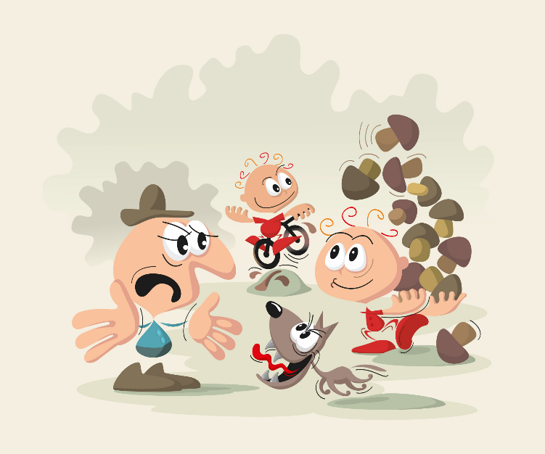

Slika : gozdni bonton (vir: https://www.studio-ajd.si/zgibanka-skrbno-z-gozdom-gozdni-bonton/)

**Gozdni bonton** je sklop preprostih, a pomembnih pravil, ki zagotavljajo, da gozd ostane čudovit in zdrav. Gozd nam omogoča rekreacijo in sprostitev. Je dom mnogim bitjem, zato je vsak obisk priložnost, da se povežemo z naravo in jo zaščitimo. Z upoštevanjem gozdnega bontona spoštujemo naravo.

V nadaljevanju je predstavljenih nekaj pravil, ki bi se jih moral držati vsak obiskovalec kočevskih gozdov:

Ko se sprehajamo po gozdu, hodimo le po uhojenih poteh, saj tako preprečimo poškodbe podrasti in zmanjšamo tveganje za lastno okužbo s klopi. Med sprehodom po učnih poteh se izogibamo lomljenju vej in trganju rastlin.

Prosto po gozdu se je prepovedano voziti z motornimi vozili. S tem namreč lahko poškodujemo gozdna tla. Vozimo lahko le po označenih poteh, kjer je to dovoljeno.

Če se sprehajamo s psom, ga imamo vedno na povodcu, ker lahko preplaši gozdne živali. Plašenje živali moti njihov dnevno-nočni ritem, aktivnosti in vpliva na količino energije, ki jo porabijo zaradi bežanja pred nami. Dodatno težavo predstavlja srečanje psa z medvedom, saj bo prestrašen pes pritekel k lastniku, s tem pa za seboj pripeljal tudi medveda.

Da bi ohranili mir in ravnovesje v gozdu, se pogovarjamo z zmernim tonom, ne kričimo in ne predvajamo glasne glasbe. Glasni zvoki vznemirjajo živali, ki živijo v kočevskih gozdovih.

Prav tako v gozdu ne kurimo ognja. Ogenj lahko uide izpod nadzora in povzroči požar, poleg tega pa onesnažuje zrak.

Zelo pomembno je, da za sabo ne puščamo smeti, kot so papirčki, plastenke in cigaretni ogorki, saj škodujejo naravi.

Zaščitenih rastlin ne nabiramo, ker tako ogrožamo njihov obstoj. Pri nabiranju gob ravnamo odgovorno – bet odrežemo le tistim, ki jih dobro poznamo, strupene ali nepoznane pa pustimo pri miru.

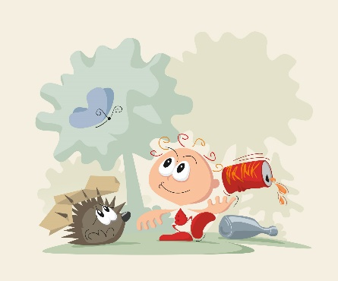

Slika : gozdni bonton (vir: https://www.studio-ajd.si/zgibanka-skrbno-z-gozdom-gozdni-bonton/)

Prav tako ne motimo gozdnih živali, ne hranimo jih in se jih ne dotikamo, saj lahko to povzroči stres in moti njihovo naravno vedenje.

Prepovedano je uničevanje gozdnih oznak, ker vsebujejo pomembne informacije in so v pomoč vsem obiskovalcem gozda.

Seveda pa ta gozdni bonton ne velja samo za kočevske gozdove, ampak tudi za vse ostale gozdove, saj je treba vse ohranjati takšne, kot so.

Gozdovi opravljajo mnoge ekosistemske storitve, ki jih človek nikoli ne bi mogel plačati gozdu. Drevesa in rastline v gozdu proizvajajo kisik, ki je nujen za naše življenje. Gozdovi pomagajo ublažiti podnebne spremembe in preprečujejo erozije tal. Nudijo hrano za ljudi in živali. Vplivajo tudi na kakovost vode in zmanjšujejo možnost poplav. Ponujajo nam mnogo dobrin, zato je naša dolžnost, da jih ohranjamo. S preprostimi dejanji lahko poskrbimo, da bo gozd ostal naravni raj, ki ga bodo lahko občudovali tudi prihodnji rodovi.

**VIRI:**

Ministrstvo za kmetijstvo, gozdarstvo in prehrano. (2024). Skrbno z gozdom. [Online]. Čas zadnje spremembe: 21. marec 2024. [citirano 19. december 2024; 12:15]. Dostopno na spl. naslovu: <https://www.gov.si/teme/skrbno-z-gozdom/>

Puschner, Marko (2012). Nabiranje gob. [Online]. [citirano 19. december 2024; 13:45]. Dostopno na spl. naslovu: <https://www.gozd-les.com/obisk-gozda/nabiranje-gob>

Puschner, Marko (2012). Gozdni bonton. [Online]. [citirano 19. december 2024; 13:50]. Dostopno na spl. naslovu: <https://www.gozd-les.com/obisk-gozda/gozdni-bonton>

Občina Semič. Gozdni bonton »skrbno z gozdom«. [Online]. [citirano 9. januar 2025; 12:20]. Dostopno na spl. naslovu: <https://www.semic.si/objava/674885>

Eva Kljun, Zala Zabukovec, ITS GRETA, GSŠ Kočevje

**FOREST ETIQUETTE**

**You have probably heard the fairy tale of the forest etiquette. Once upon a time, a man stepped into the forest. He polluted it and destroyed its natural beauty. There was rubbish all over the ground, plants were destroyed and animals were frightened. All of a sudden, a bear appeared and chased the man away for his terrible actions. The bear was horrified because the man had destroyed his home.**



Picture 1: forest etiquette (source: [https://www.studio-ajd.si/zgibanka-skrbno-z-gozdom-gozdni-bonton/)](https://www.studio-ajd.si/zgibanka-skrbno-z-gozdom-gozdni-bonton/)ž)

Forest etiquette is a set of simple but important rules that ensure that the forest remains beautiful and healthy. In the forest you can engage in recreation and relaxation. The forest is home to many creatures, and every visit should be an opportunity to connect with nature and protect it. By observing forest etiquette, we respect nature.

Here are some rules that every visitor of Kočevsko forests should follow:

When you walk through the forest, walk only on well-trodden paths to prevent damage to the undergrowth and to reduce the risk of our own tick infection. While walking along the educational paths, avoid breaking branches and picking plants.

It is forbidden to drive motor vehicles on forest paths and skid trails, because this damages the forest ground. It is only allowed to drive on forest roads.

If you go for a walk with a dog, always keep it on a leash because the dog can scare forest animals. Scaring animals disrupts their day-night rhythm, their activities and the amount of energy they use because of running away. An additional problem could be the meeting of your dog with a bear, because a frightened dog will run to its owner and bring the bear with it.

To maintain peace and balance in the forest, talk with a moderate tone, do not shout or play loud music. Loud noises disturb forest animals.

Do not light a fire in the forest. A fire can get out of control and cause a forest fire, and it also pollutes the air.

It is very important not to leave behind waste and trash, such as paper, bottles, cans and cigarette butts, because they harm nature.

Do not pick protected plants, because this threatens their existence. When picking mushrooms, act responsibly – cut the stalk from those you know well, and leave poisonous or unknown ones alone.



Picture 2: forest etiquette (source: https://www.studio-ajd.si/zgibanka-skrbno-z-gozdom-gozdni-bonton/)

Also do not disturb, feed or pet forest animals, because this can cause stress and it disrupts their natural behaviour.

It is forbidden to destroy forest signs, because they contain important information and help forest visitors.

Of course, this forest etiquette does not apply only to Kočevje forests, but generally.

Forests provide many ecosystem services that the forest could never be paid for. Trees and plants in the forest produce oxygen, which is vital for our life. Forests help mitigate climate change and protect soil erosion. They provide food for humans and animals, affect the water quality and prevent flooding. They provide us with many goods, so it is our duty to preserve them. With simple actions, we can ensure that the forest remains a natural paradise for us and for future generations to enjoy, admire and appreciate.

**SOURCES:**

Ministrstvo za kmetijstvo, gozdarstvo in prehrano. (2024). Skrbno z gozdom. [Online]. Čas zadnje spremembe: 21. marec 2024. [citirano 19. december 2024; 12:15]. Dostopno na spl. naslovu: <https://www.gov.si/teme/skrbno-z-gozdom/>

Puschner, Marko (2012). Nabiranje gob. [Online]. [citirano 19. december 2024; 13:45]. Dostopno na spl. naslovu: <https://www.gozd-les.com/obisk-gozda/nabiranje-gob>

Puschner, Marko (2012). Gozdni bonton. [Online]. [citirano 19. december 2024; 13:50]. Dostopno na spl. naslovu: <https://www.gozd-les.com/obisk-gozda/gozdni-bonton>

Občina Semič. Gozdni bonton »skrbno z gozdom«. [Online]. [citirano 9. januar 2025; 12:20]. Dostopno na spl. naslovu: <https://www.semic.si/objava/674885>

Eva Kljun, Zala Zabukovec, ITS GRETA, GSŠ Kočevje